Cayes Drive
(Submitted and Approved as Stonecreek PUD Section 1 December 20, 1999)
Drainage Report: December 6, 1999 (no 100-year overflow given)
Drainage Plan: Sheet 3 dated December 6, 1999 (not the latest plan and no borrow basin shown)
Drainage Detail: Sheet 6 dated December 6, 1999 (no borrow detail shown)
Drainage Plan: Sheet 3 dated January 6, 2000 (Cross-Section B-B, P-644, Flag Gate 645)
Co Eng. Letter: dated 09-22-00 (unable to find)
Stonecreek PUD Sec. 2 Ph 1 As-Built Plan: Sheet 1 dated 4-18-00 latest revision 8-07-01
Stonecreek PUD Sec. 2 Ph 1 Street and Storm Sewer Acceptances: dated 09-10-01
Stonecreek PUD Sec. 2 Ph 2 As-Built Plan: Sheet 1 dated 9-02-03 (No Cross-Section, P-644, Flap Gate 645 not shown)
Stonecreek PUD Sec. 2 Ph 3 As-Built Plan: Sheet 1 dated 9-02-03
Stonecreek PUD Sec. 2 Ph 2,3 Street Acceptance: dated 11-10-03
Stonecreek PUD Sec. 2 Ph 2,3 Street and Storm Sewer Acceptance: dated 12-08-03 (P-644, Flap Gate 645 not shown)

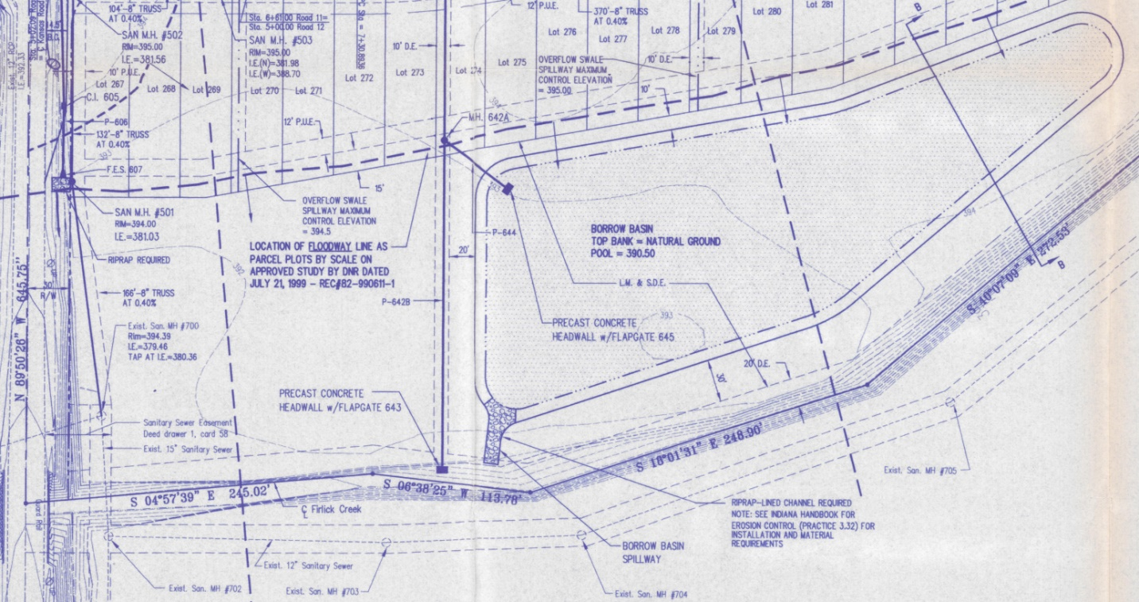
Drainage Plan: Sheet 3 dated January 6, 2000 (Cross-Section B-B, P-644, Flag Gate 645)

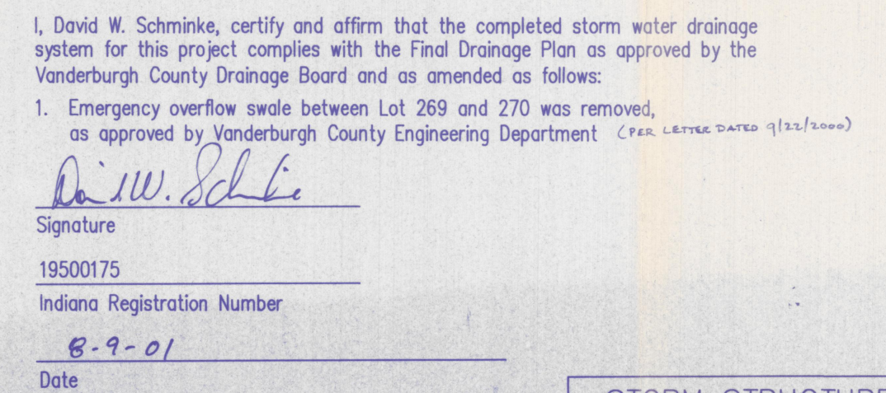
Stonecreek PUD Sec. 2 Ph 1 As-Built Plan: Sheet 1 dated 4-18-00 latest revision 8-07-01
Co Eng. Letter: dated 09-22-00 (unable to find)

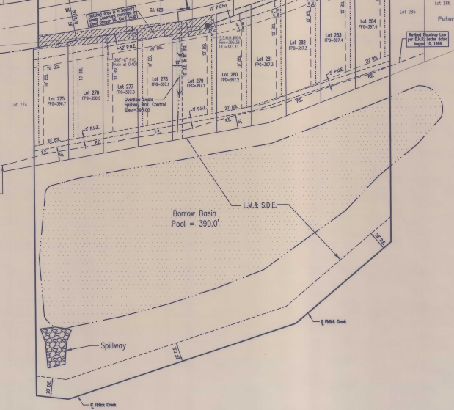
Stonecreek PUD Sec. 2 Ph 2 As-Built Plan: Sheet 1 dated 9-02-03 (No Cross-Section, P-644, Flap Gate 645 not shown)

